2009 Consumer Confidence Report

Public Water System ID 02600W

IS MY DRINKING WATER SAFE? Hartstene Pointe Water-Sewer District meets or exceeds all Federal and State water quality standards. Each month the trained staff takes a sample from the distribution system to test for coliform bacteria. Of the 12 samples that were taken in 2009, none were unsatisfactory. Other water quality data is listed below:

Inorganic  Contaminants  EPA Regulated (Primary) | MCL | MCLG | Range of Sample Detections | In Range | Typical Source of Compliance Contaminant
Nitrate (ppm) | 10 | 10 | <0.2 | Yes | Erosion of natural deposits
Arsenic (ppm) | N/A | 10 ppb* | <10 to 30 ppb | Yes | Erosion of natural deposits
Copper (ppm) | N/A | 1.3* | <0.02 | Yes | Corrosion of plumbing
Lead (ppm) | N/A | 0.015* | <0.002 | Yes | Corrosion of plumbing
Radionuclides **
Gross Alpha (pCi/l) |  |  | Not Detected | Yes | Erosion of natural deposits
Gross Beta (pCi/l) |  |  | Not Detected | Yes | Erosion of natural deposits
Trihalomethanes

Maximum Total (ppb) | *** |  | Not Detected | Yes | Byproducts of chlorination

* The Maximum Contaminate Level Goal (MCLG) listed for arsenic, copper, and lead are levels above which the District must take corrective action. The action level for lead and copper must be exceeded by at least four samples out of thirty takes.
**Radionuclides were not required to be tested in 2009.
*** There is no Maximum Contaminate Level (MCL) for maximum total trihalomethane potential (MTTP). When the value exceeds 100 ppb, the purveyor is required to take follow up action. The District does monitor one well for MTTP on a quarterly basis. Additional monitoring has shown the level below the 100 ppb level.

Iron: The primary impact of iron and manganese has been to impair the aesthetic quality of the drinking water by forming precipitates in the water distribution system. Elevated levels of iron and manganese can cause reddish to black colored water, stain laundry and porcelain fixtures, promote bacterial growth in the distribution system, and in high concentrations, cause metallic tastes. Both wells exceed the maximum contaminant level (MCL) levels for iron and manganese. The District uses greensand filter to treat the water for iron and manganese.

Arsenic: Water from Well 2 exceeds the arsenic maximum contaminant level (MCL) and has a State approved treatment system to lower the level of arsenic to an acceptable level.

WHAT IS THE SOURCE OF MY DRINKING WATER?

Your water comes from our two wells, which pump 75 and 100 gpm respectively. Our drinking water is chlorinated.

WHY ARE THERE CONTAMINANTS IN MY DRINKING WATER? Drinking water, including bottled water, may reasonably be expected to contain at least small amounts of some contaminants. The presence of contaminants does not necessarily mean that water poses a health risk. More information about contaminants and potential health risks can be obtained by calling the Environmental Protection Agency’s Safe Drinking Water Hotline; 1-800-426-4791. For more information about your drinking water please call us at (360) 876-2545.

HARDNESS The hardness of the District’s water varies widely from well to well. The hardness varies between 96 and 101 mg/l measured by Standard Methods 2340 B. The range for moderately hard water is 51.3 to 119.7 mg/l or 3.5 to 7 grains per gallon.

IS OUR WATER SYSTEM MEETING REGULATIONS THAT GOVERN OUR OPERATIONS? Yes. The State and EPA require us to test our water on a regular basis to ensure its safety. We did not have any violations of primary drinking water standards during 2009. The water from both of our wells exceeds the secondary standard for iron and manganese. There are no adverse health effects from iron and manganese in drinking water at the levels found. One District well does contain a level of arsenic which requires treatment. That treatment was installed in 2008.

DO I NEED TO TAKE SPECIAL PRECAUTIONS? Some people may be more vulnerable to contaminants in drinking water than the general population. Imuno-compromised persons such as persons with cancer undergoing chemotherapy, persons who have undergone organ transplants, people with HIV/AIDS or other immune system disorders, some elderly, and infants can be particularly at risk from infections. These people should seek advice about drinking water from their health care providers. EPA/CDC guidelines on appropriate means to lessen the risk of infection by cryptosporidium and other microbial contaminants are available from the Safe Drinking Water Hotline (800-426-4791)

With the treatment, our drinking water currently meets EPA’s revised drinking water standards for arsenic. There is a small chance that some people who drink water containing arsenic for many years could develop circulatory disease, cancer, or other health problems. Most types of cancer and circulatory diseases are due to other causes than exposure to arsenic. EPA’s standard balances the current understanding of arsenic’s health effects against the cost of removing arsenic from drinking water.

Hartstene Pointe Water-Sewer District is governed by three Commissioners elected by the voters within the District. The District Board of Commissioners meets on the second and fourth Thursdays of each month at 1:00 PM. The public is invited to participate.

The General Manager is the responsible for the water system and his telephone number is (360) 876-2545. Our web page is www.hartstenepointe.us

WATER QUALITY DATA The enclosed tables list all the drinking water contaminants that we detected during the most recent sampling. The presence of these contaminants in the water does not necessarily indicate that the water poses a health risk. The data is a compilation of the individual well data. The State of Washington does not require us to monitor for certain contaminants every year because the concentrations of these contaminants are not expected to vary from year to year.

To assist in better understanding this information, the following definitions are provided:
EPA Environmental Protection Agency ppb parts per billion
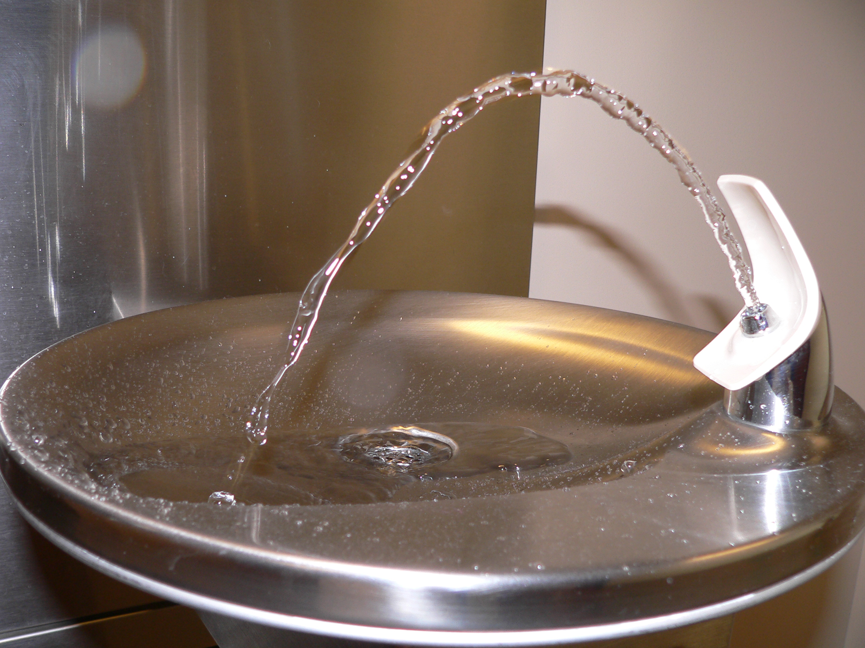
mg/l milligram per liter ppm parts per million
ug/l microgram per liter ml milliliter
< Less than ND Not Detected
NTU Nephelometric Turbidity Unit
Umhos/cm micromhos per centimeter

Maximum Contaminant Level or MCL: The highest level of a contaminate that is allowed in drinking water. MCLs are set as close to the MCLGs as feasible using best available treatment technology.
Maximum Contaminate Level Goal of MCLG: The level of a contaminant in drinking water below which there is no known or expected risk to health. MCLGs allow for a safety of margin.

EPA REGULATED INORGANIC COMPOUNDS
COMPOUND | MCL, mg/l | HIGHEST QUANTITY DETECTED, mg/l
Arsenic | 0.01 | 0.030 | 0.01 ppm and 0.01 mg/l is the same as 10 ppb
Cadmium | 0.005 | <0.1
Chromium | 0.1 | <0.001
Mercury | 0.002 | <0.0005 | Safe Drinking Water Hotline  1-800-426-4791  www.epa.gov/ogwdw
Selenium | 0.05 | <0.005
Beryllium | 0.004 | <0.003
Nickel | 0.1 | <0.04
Antimony | 0.006 | <0.005
Thallium | 0.002 | <0.002
Cyanide | 0.2 | 0.05
Fluoride | 4 | 0.2
Nitrite-N | 1 | <0.2
Nitrate-N | 10 | <0.2

(Secondary Compounds)
COMPOUND | MCL, mg/l | HIGHEST QUANTITY DETECTED, mg/l
Iron | 0.3 | 0.34
Manganese | 0.05 | 0.31
Silver | 0.1 | <0.01
Chloride | 250 | 5
Sulfate | 250 | 2
Zinc | 5 | <0.2

State Regulated
COMPOUND | MCL, mg/l | DETECTED
Sodium |  | 11 mg /l
Hardness |  | 101 mg/l
Conductivity | 700 umhos/cm | 203 umhos/cm
Turbidity | 1 | 0.9 NTU
Color | 15 color units | 10 color units

WAIVERS: The Washington State Department of Health has reduced the monitoring requirements for herbicides, insecticides, and pesticides because our sources are not at risk of contamination.

